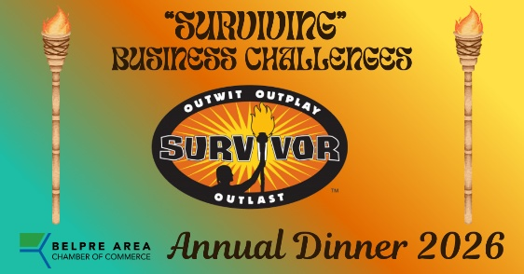

June 10, 2026

Dear Belpre Area Business Community Supporter,

Belpre Area Chamber of Commerce Board of Directors cordially invites you to be a part of our signature event as we gather for the 88th Belpre Area Chamber of Commerce Annual Dinner, with a nod to the 50th season of the television series “Survivor”. Our theme is “Surviving Business Challenges”.

We invite members and guests to join us Thursday, October 22, 2026, 5:30 pm at Grand Pointe Conference and Event Center, 1500 Grand Central Avenue, Vienna, WV. That’s “Day 22” of the month!

The Special Events Committee is committed to presenting an enjoyable experience with a vital “take-away” of information for all who attend. We will be presenting a special evening of food, social gathering, and business networking. Our “final tribal council” will present the “challenges” of owning and managing a business. But no one gets “voted off” the island if they have “immunity”!

Yes, there WILL be tiki torches!

We are currently seeking sponsors and would be honored to have your business or organization sponsor our dinner this year. This event attracts approximately 250 guests yearly, and we enthusiastically invite you join us in this celebration of business in the Belpre Area. Again, we will use video to highlight our major sponsors.

PLEASE REVIEW THE SPONSORSHIP OPPORTUNITIES ON THE NEXT PAGE. You are welcome to send the sponsorship pledge to our office. We will gladly accept payment by check, cash or credit card. Call the office to process your card.

SPONSORSHIP OPPORTUNITIES

Businesses, non-profits, and community leaders gather for this showcasing and networking opportunity. Your business will receive maximum exposure by joining those who sponsor the event. Please review the sponsorship packages listed below. A response sheet is enclosed for your convenience. Extra dinner tickets will be available for $70.

Platinum Plus sponsor- $1500 (1-2 available)
Exclusive recognition in the appetizer area including signage recognizing this sponsorship. 15-second business spotlight in opening video with company spokesperson. Logo on all event materials, and sponsor recognition in all media & promotional opportunities (press releases, advertisements, social media). Includes 8 dinners and seating near the speaker ($560 value).

Platinum Sponsor - $1200 (up to 6 available)
15-second business spotlight in opening video with company spokesperson. Logo on all event materials and sponsor recognition in all media & promotional opportunities (press releases, advertisements, social media). Includes 8 dinners and seating near the speaker ($560 value).

Gold Sponsor - $600 (up to 10 available)
Logo on all event materials. Sponsor recognition in all media & promotional opportunities (press releases, advertisements, social media). Includes 4 dinners with preferred seating ($280 value)

Award Sponsor-$400 per award
Sponsorship earns the privilege of presenting the plaque containing YOUR name as sponsor to the winner during the dinner, plus 2 complimentary dinners and preferred seating ($140 value). (Example: “Business of the Year”, “Citizen of the Year”, etc.)

Bronze Sponsor- $350 (up to 20 available)
Logo on all event materials and sponsor recognition in all media & promotional opportunities (press releases, advertisements, social media. Includes 2 dinners and preferred seating ($140 value).

Contact me at 740-423-8934 or by email at info@belprechamber.com with any questions. We truly appreciate your consideration, and I thank you in advance for your support of Belpre Area Chamber of Commerce and the communities in which we work.

Please return the enclosed form to secure your sponsorship. You will be appropriately invoiced if necessary. Please contact our office to pay by credit card. Your guest names will be confirmed by a member of our staff.

Please send us a current high-resolution logo to info@belprechamber.com

Sincerely,

Karen Waller
Executive Director

 BACC ANNUAL DINNER 2026
SPONSOR PLEDGE/PAYMENT

Business Name__________________________________

Contact Person Name______________________________ Phone___________________

Mailing Address_______________________________________
E-mail Address ___________________________________________________

Sponsor Level: (please check the level you wish to purchase)

____Platinum Plus $1500 ______Bronze $350

____Platinum $1200 ______ Award $400

____Gold $600

______Please send me/us a receipt for payment received.

______Please invoice me/us. Amount Due_$_________________

Note: Extra dinner tickets can be purchased in addition to the complimentary tickets included in your sponsorship.

Number of additional tickets @$70___________

Total ticket purchase___________

Total pledge/purchase:_$__________________
Call our office 740-350-4692 for credit card processing.

Please return this form as your sponsorship pledge or with payment to:
(Remember to send us a high-resolution logo to info@belprechamber.com)

Belpre Area Chamber of Commerce
713 Park Drive
Belpre, OH 45714

